The Brightspace login screen has two options for logging in: NHSBT Login and Manual Login.
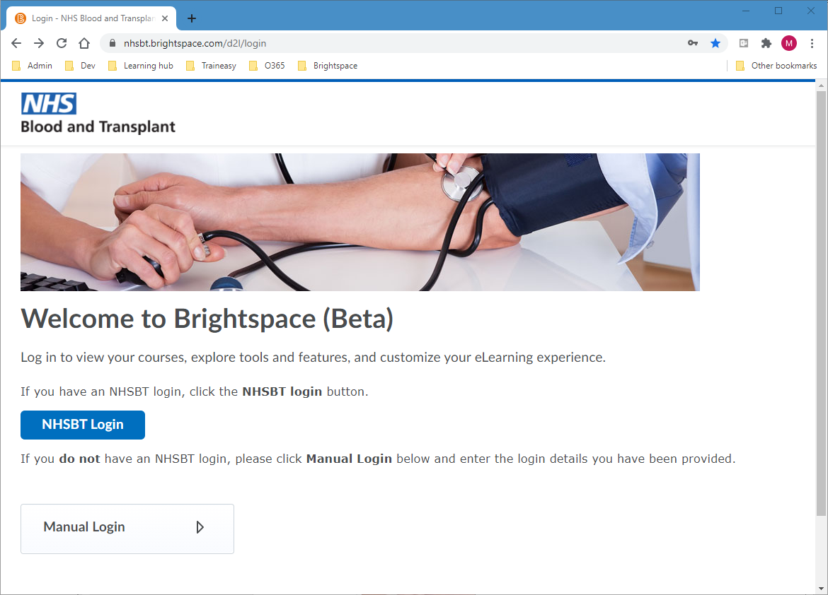
If you have an NHSBT IT login, then you must use the NHSBT Login button.
Note: Do not use the Manual Login option. This will not work if you have an NHSBT IT login and should only be used by those that do not, e.g. external learners.
Once you click the NHSBT Login button, what you see next depends on which type of device you are using and whether you are already logged into any NHSBT online services (such as Link, Sharepoint etc.).

NHSBT computer or laptop
The login process is identical to that used to access Link, Sharepoint etc.
- Click the NHSBT Login button on the Brightspace login screen.
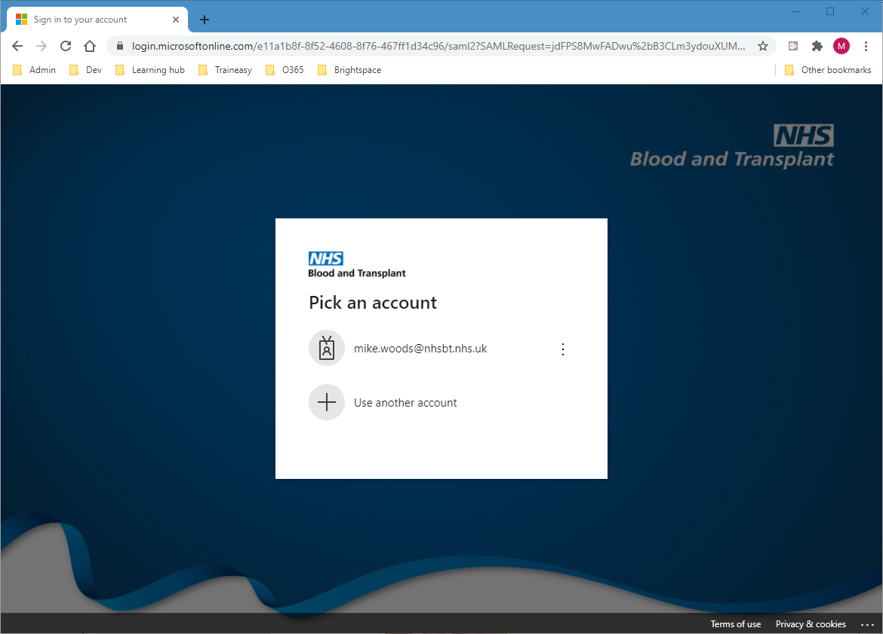
- Select your account (this option will be skipped if you are already logged into an NHSBT online system).
After this you will be logged onto Brightspace and the home page will be displayed.
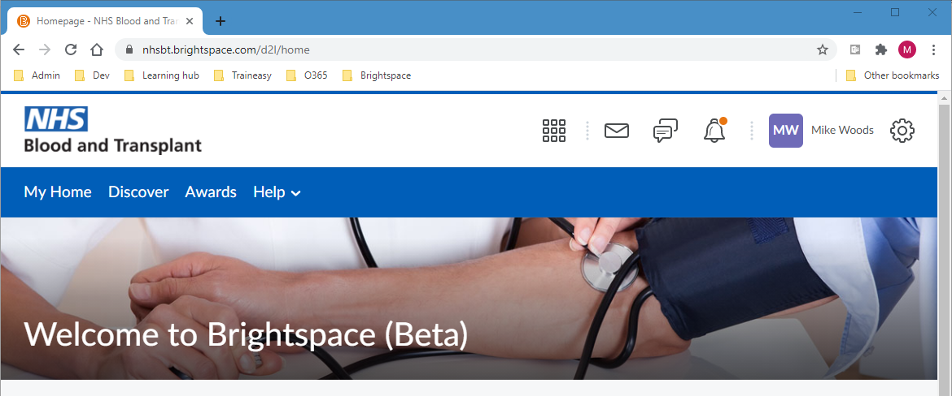

Shared tablet
On shared tablets we recommend that you use the browser on the device to access Brightspace, as it is simpler to log out of Brightspace after your session so that another user can then log in.
The login process is identical to that used to access Link, Sharepoint etc.
- Click the NHSBT Login button on the Brightspace login screen.
- Enter your email address and click Next.
- Enter your NHSBT password and click Next.
Important: Do not tick the Don’t show this again tickbox, or click the Yes button, otherwise other users of the tablet may be logged into your account!
- Click the No button, after which you will be logged onto Brightspace and the home page will be displayed.

Individual or personal mobile device (phone or tablet)
On these devices you have a choice. You can either login via the browser on the device or you can download the Brightspace Pulse app from the application store.
In either case, the login process will take you to the Brightspace login screen.
- Click the NHSBT Login button on the Brightspace login screen.
- Enter your email address and click Next.
- Enter your NHSBT password and click Next.
- Tick the Don’t show this again tickbox.
- Click the Yes button, after which you will be logged onto Brightspace and the home page (in the browser) or course list (in the app) will be displayed.

