[*NB. This must be agreed between Management and Staff Side before the document can be published]

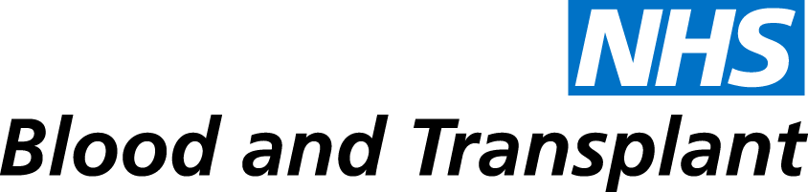
[DIRECTORATE]
[Name of Change Programme]
[Location]
Final Decisions Document

Ensure that you follow this template as closely as possible; however, it may be necessary to amend it due to the specific needs of the change initiative. Operational and HR Leads should ensure they agree the content with staff side prior to publication.

1. Introduction
[Brief introductory summary]

2. Rationale and Background to the Proposed Change
[Provide a full description of the reason/s for the agreed change. This should link to the appropriate NHSBT Strategy and should include any evidence to support the need for change.]

3. Main Changes
[This should describe all the changes that have been agreed]

4. Consultation Outcome
[Description of the consultation process including the approach taken, when meetings were held, information distributed and how, and any details that need to be highlighted from these meetings]

5. Implementation Plans
[Details of how the changes will be implemented, including time scales and any further actions required as part of the implementation process such as review meetings]

6. Individual Consultation
[Details of when these are planned to commence and conclude, and employees will be informed of this]

7. Mitigation of Impact of Proposals
[Minimising Redundancy - Reconfirm the measures that will be adopted in order to minimise compulsory redundancies i.e. no recruitment in the meantime, stopping over time etc

Provide details as to whether voluntary redundancy applies, how this will be handled and what criteria will apply. Description of a clear process to include time scales and how staff can access this]

[Redeployment- Identify the redeployment process that will be applicable for those identified at risk]Speak to HR Change Admin for additional guidance
Relocation-Highlight if relocation arrangements are applicable
At Risk-Details about how staff will be informed if they are at risk
Support Details of additional support available such as Learning and Development workshops and dates of these if arranged. Details of how employees can apply to attend these workshops]

8. Conclusion
[Reconfirm the changes agreed on and when they will commence]

9. Feedback Process for Staff, Staff Representatives and other Stakeholders
[Set out how]
10. Equality Impact Assessment
[if there has been a change in collective consultation that will impact on the original EIA, this will also need to be updated. The updated EIA will replace the original document on SharePoint. State here any changes made]

