Top tip: When you initially start to complete your requirement, you will need to select an appropriate role description from a list of Requirement Templates. Your Search criteria is best done as follows dependant on the type of role you are trying to fill:

Managers and Specialist Contractors – Enter most appropriate key words (These roles will generally be provided at Contractors day rates)
Admin And Clerical – Enter “AFC” this will bring up a list of admin and clerical roles at each AFC band level to choose from
Operational Roles – Enter “NHSBT” this will bring up a list of the most used NHSBT operational roles for agency purposes to choose from

Issue | Fieldglass Asks: | Specific details | Your Response
Criminal Record Checks  (Disclosure and Barring Service – “DBS”) | “Please provide any information specific to this role” | No DBS/ Criminal Records question is asked so enter details in this free text field | Where a DBS check is required for the role specify this requirement here including which level (standard or enhanced). If you are unsure, please refer to the “List of Posts requiring Disclosure and Barring Service Checks” which can be found here:  posts requiring DBS Checks
Pay – Allowances | “Please provide any information specific to this role” | If allowances are payable, please enter detail in this free text field. | Enter details of any allowances which the agency worker is entitled to. If unsure of these this is available in the NHSBT Agency Workers Salary Rates and Allowances guide.
Health and Safety Requirements/ Occ Health | “Are there Any Health and Safety Requirements or hazards associated with this role?” | N/A | Enter Yes or No as appropriate
 | “If Yes please enter the Health and safety considerations” | Immunisations: | Inform the agency if the role is likely to involve contact with Blood or body fluids. Where this is the case the Agency will need to inform the prospective worker and give them the option of immunisation. The Agency will need to make arrangements for this if the worker does request this.
 |  | PPE | Where Safety Boots will not be provided by NHSBT please specify:  Footwear must meet the following specification:  “BS EN 20345:2011 - protective footwear with toe protection to 200 joules.  The colour must be black and the sole must have a slip resistant sole”
IR 35 – tax assurance | “Is this Role in or out of scope of IR35?” | Must be completed for ALL requirements | You must respond for all requirements in line with NHSBT policy for all agency workers as follows:  “The Role is in scope of IR35”
Screening | Level of Screening | Pre-employment checks | Fieldglass does not currently allow us to choose NHS Employment Check Standards. The arrangements in place if the above instructions are followed will ensure that the correct steps are taken to comply with our standards.  Please select “BPSS (HMG Baseline Personnel Security Standard)” from the list provided
Requirement Approvals. | Once you have submitted your requirement you will need to add an appropriate step 4 approver. | Requirements should be approved by your Budget manager or by a Purchasing Administrator if evidence of Budget Holder approval is provided. | After Submitting, click on the Approvals / Audit Trail.  Add an approver at step 4.  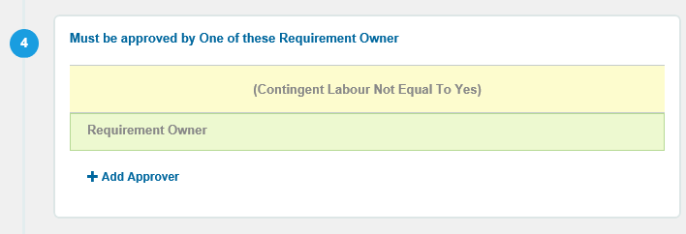  You can add purchasing@nhsbt.nhs.uk if you have evidence of Budget Holder approval.  Alternatively, a list of budget holders / approvers can be found here.

