To book your place on the Practical Introduction to Transfusion Science course (PITS)
- From the NHSBT Learning Centre https://learningcentre.nhsbt.nhs.uk Click the Student Login option
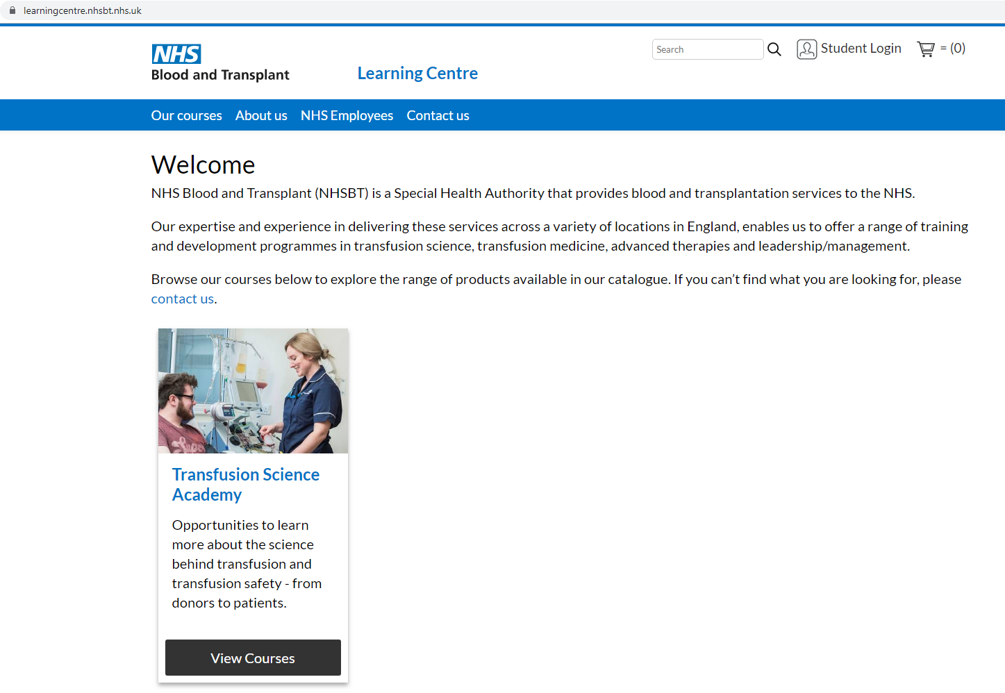
- You are already registered so select the option to Login
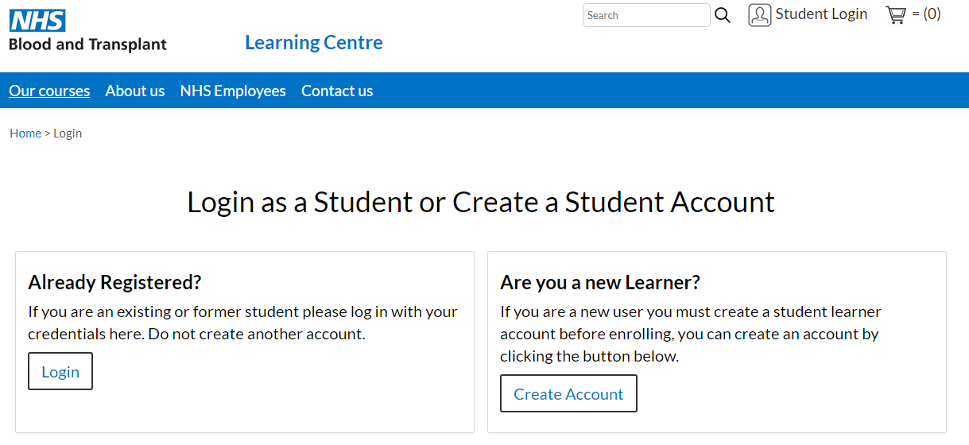
- Click on the option NHSBT Login to access your Brightspace account
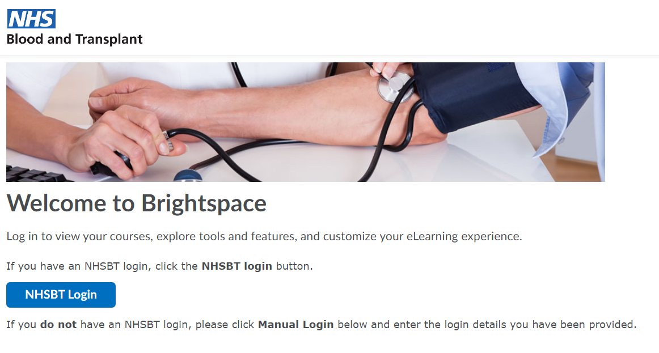
- By selecting Continue you will be redirected back to the NHSBT Learning Centre to book your course.
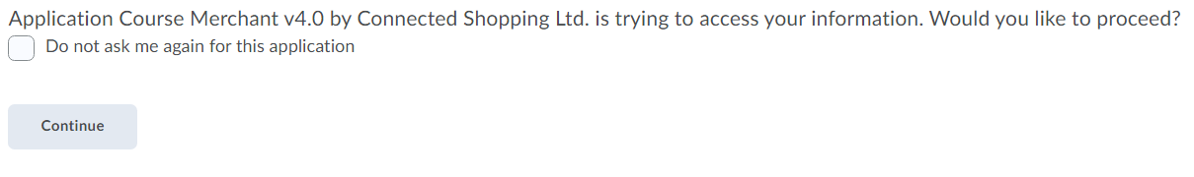
- View Courses (you can also search for a course but currently only PITS is available)
- View Details
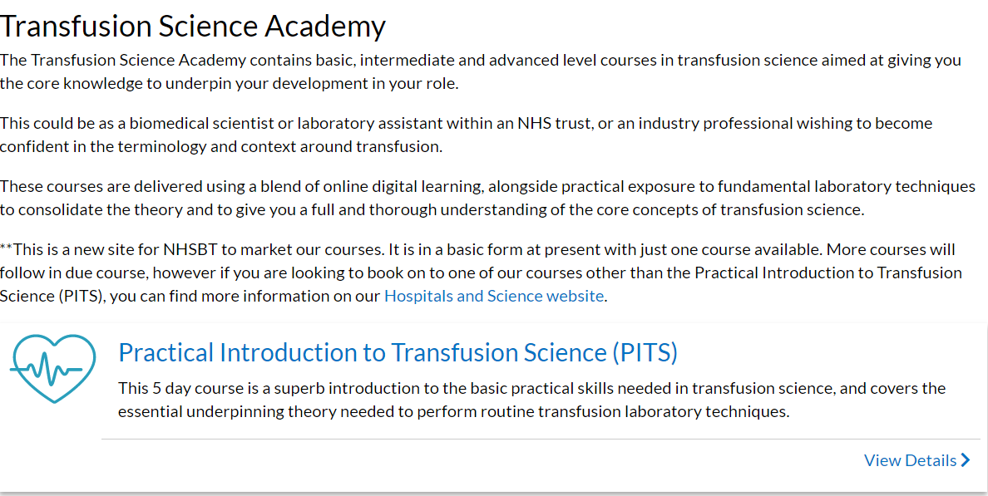

- Select your two sessions, theory and practical ensuring your theory date comes first and Add to Cart
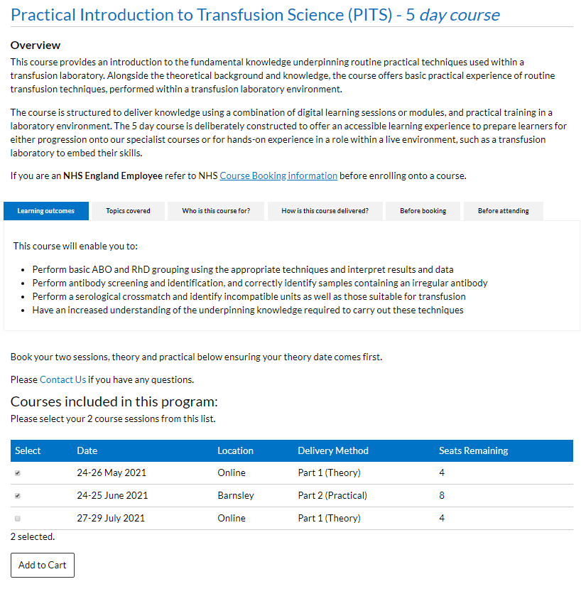
- Check that your booking is correct and then Checkout
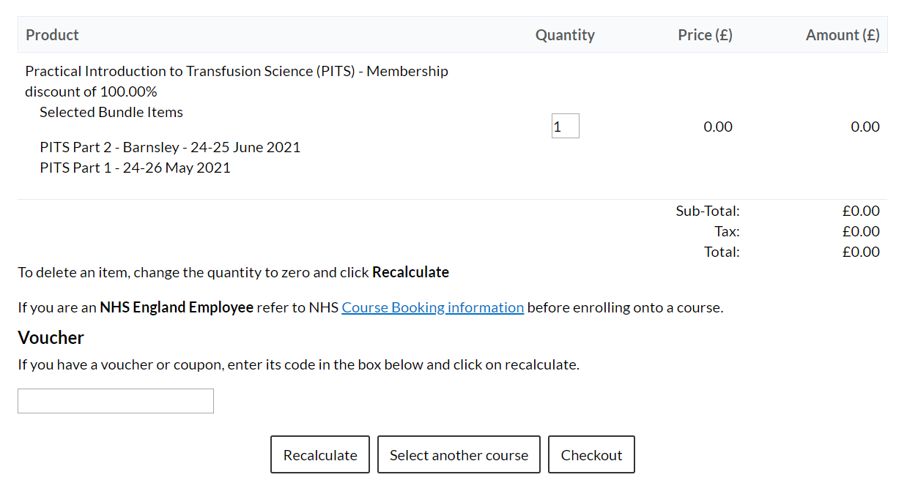
- Your booking details will be displayed and you will be prompted to enter some address information. Please enter NHSBT in any required address field and then click to agree to the terms and conditions of booking and the option to Proceed.
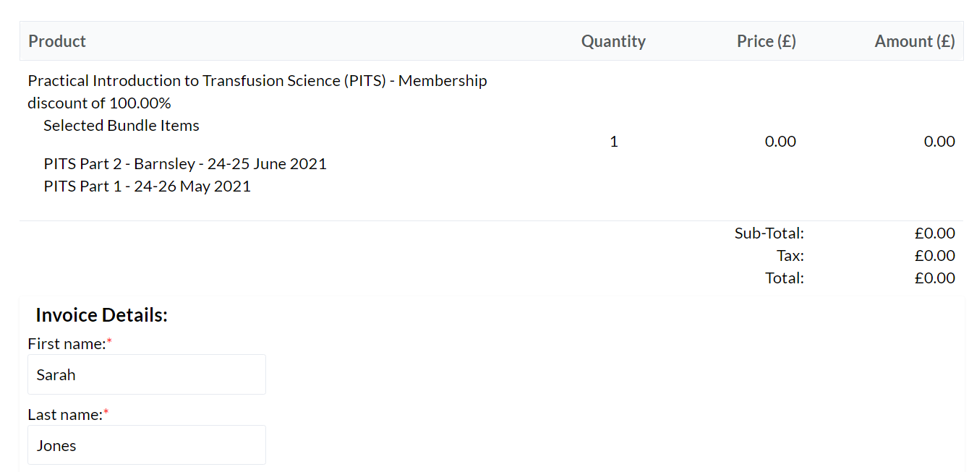
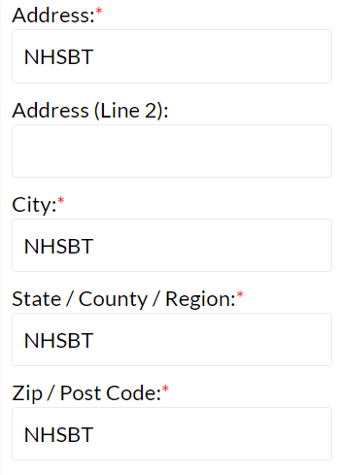
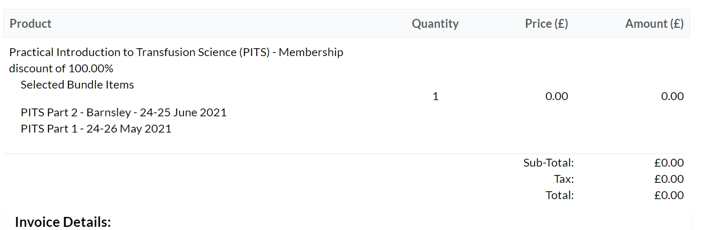
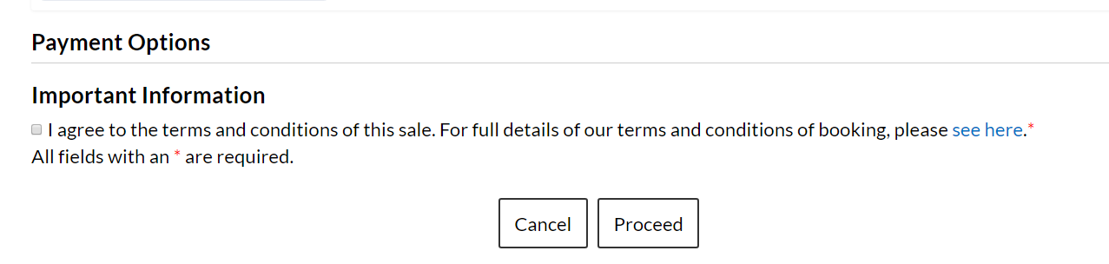
Note that there is no charge to NHSBT Employees for attending nor are any cancellation charges applicable.
- Your booking will be confirmed (you will also receive a separate email confirmation). You are now enrolled onto the course and can view this in Brightspace by clicking the link below.
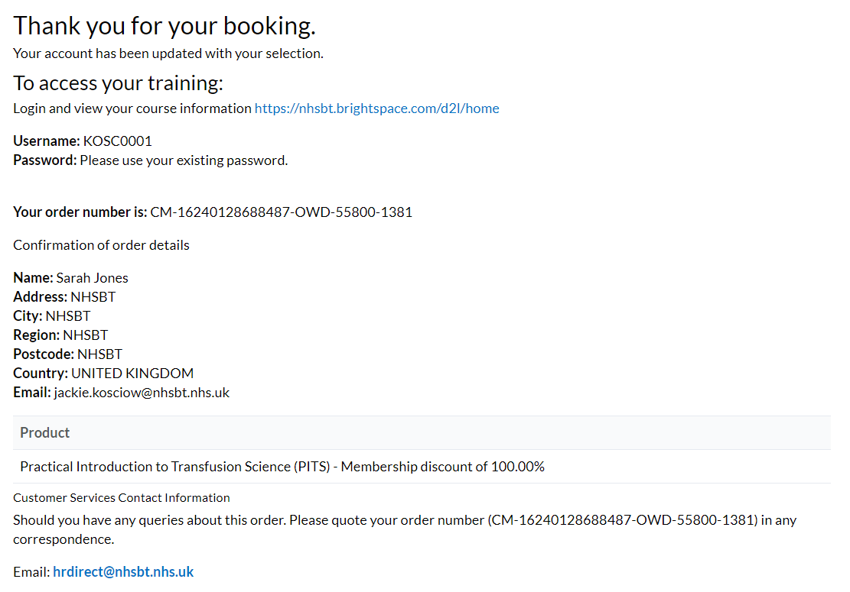
Note:
Joining Instructions are included as part of the course enrolment process and can be viewed in Brightspace. Remember to make a note in your calendar of the course date.

